Case study

Sai Gowtham Tammineni

Implementation of seamless CI/CD workflow of streamline webapp.

Project Management Setup

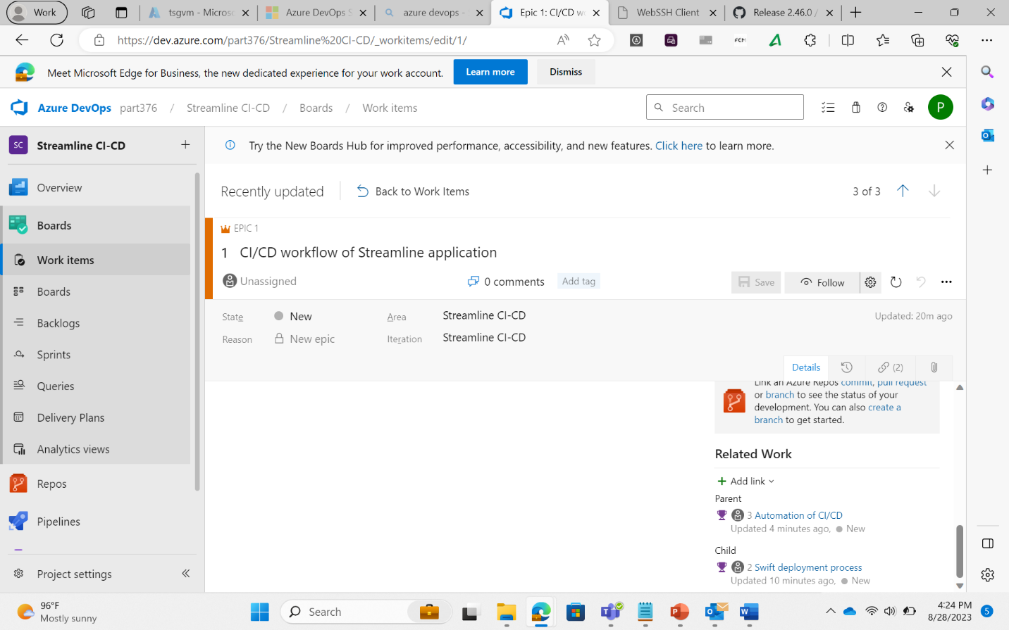

Github repository and feature branching

Azure VM configuration

Respective Location :- US east 2

Resource Group – RBDK

Storage - B2s

Image- Ubuntu

Username- streamline

Password-Pa$$w0rd1234

Standard HDD

Network IP - Basic Dynamic Public IP.

Mavin based build process

VM is conneceted using ssheasy.com

Latest version of mavin is installed. The source code from github is cloned into mavin and compiled into JAR.